

Doriela Grabocka

June 2020

Web Systems Developmenet

Project: Student Management System

**Contents**

**Website Purpose** 2

**UML Use Case Diagram** 2

**High Level Design** 4

**Database Schema** 6

**Website Usage** 6

**How to use the application** 15

# **Website Purpose**

Student Management System is a web based system to be used in a university. Its main aim is to facilitate the work of the administration of the university. It will help people working in the Records Office to add new students, add new courses to the list of courses, search for students and search for courses. Moreover, the users would be able to assign or register a student to a course.

# **UML Use Case Diagram**

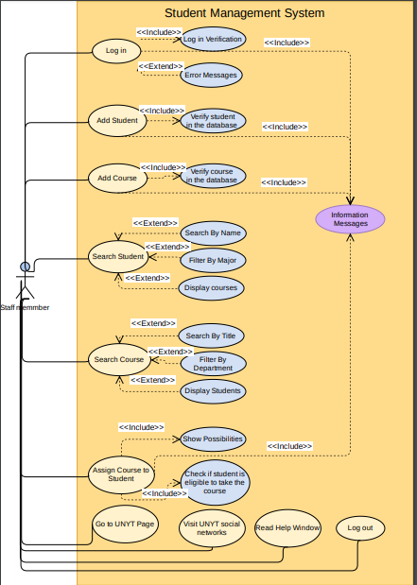

From the Use Case diagram, the functionalities of the system are clear. The user can log in, add a course, add a student, search for a student, search for a course, filter students and courses, check courses of a student check students of a course and assign a course to a student. Whenever the user logs in, the login verification happens. In the cases when the verification process fails, then the appropriate error message is displayed.

Appropriate information messages are always displayed when the user adds a student, adds a course or assigns a course to a student. They will indicate the status of the operation: whether the operation succeeded or not.

Moreover, as it is seen the diagram the user has the possibility to read the help window, go to UNYT website, visit the social networks of UNYT and log out as well.

New users can be registered. In order for the new users to be registered, they should have an official email from the institution that in the case of the system should be an official email of UNYT ending in @unyt.edu.al. Moreover, the users have the options to directly go to the web page of the university as well as visit the social networks of the institution for the latest news.

When registering a new student or a new course, they will be added only if the student or the course are not registered already. Students are checked by their email, since no 2 people can have the same personal email. While for a certain course, the time, the title, the instructor and the day will be checked against records in the database. Otherwise, a message will be displayed indicating the situation.

When searching for a student, the user has the possibility to enter the name or part of it and the system will display the corresponding students. On the other hand, the user has the possibilities to filter students by their major. In order to see the courses of a particular student, the user can click on the student on the table and then press the Courses button. All the courses of a student will be displayed in a second table below the first one. The textbox with the studentID is read only so that the user cannot enter an ID that does not exist.

When searching for a course, the user has the possibility to enter the full course name or part of it. Then the system will display the course and the corresponding details. The user has he possibility to filter the courses by department. Moreover, by clicking on a particular course the user can see the students enrolled on that course. The textbox with the courseID is read only so that the user cannot enter an ID that does not exist.

When adding the course the system makes some validations prior to enrolling a student in a course. First, it makes sure that a user can view the possible course that a student can take. This happens because the second table holding the possible courses of a student appears only after the user has selected a student form the table. Then when the user selects a course from the second table and presses the button to enroll a student, the system will search if a user has the course already or not. If not the student will be enrolled. Otherwise, it will not be added. In both cases, an information message will be displayed indicating the situation. All input fields are read-only here, so that the user cannot enter something explicitly. This is done in order to make validation easier and faster.

The users cannot edit the data once they have submitted them. The IT staff can only edit them by changing directly the database. This is done for security purposes.

# **High Level Design**

The project has two parts: the stylesheets in a CSS folder and the PHP scripts that contain inside the html code. The CSS folder contains the stylesheets of every PHP file. Each PHP file corresponds to a separate window that is opened when the user request a functionality of the system. I have used two external scripts, one for jQuery and another for displaying the Ion Icons.

LogInValidation.php, sessionCheck.php, database.php, closeDatabase.php are the only PHP scripts that do not contain HTML code. Their purpose is not to display anything on the webpages. They are used for database connectivity and validations.

* **database.php** – used to connect with the database.
* **closeDatabase.php**- used to close the connection with the database. It uses a closeConnection function that closes the connection.
* **sessionCheck.php** – used to determine whether a user has logged in or not. It is used inside all the pages except of login in order to prevent unauthorized access. It checks whether some session variables are set or not. If yes the access is allowed otherwise the user who is attempting to open a page will be redirected to the login window.
* **logInValidation.php** – is the scripts that uses the code of database.php script to get the connection variable and to request data from the database that correspond with the username and password that the user has entered. Then in the form of an associative array, it indicates whether the login operation succeeded or failed. It performs the validation by using a function called validateLogIn that receives two parameters the name and the password entered by the user. After opening the connection then it constructs a query in order to receive from the database the user with the given username and password. If nothing is found that it means that, the data provided by the user are not correct. The function return an associative array indicating the information message returned by the operation as well as the status of the operation.

Scripts that contain HTML and PHP code:

* **login.php** – used to login to the system. Once the validation has passed, two session variables are set: $_SESSION[“nameOfUser”] and $_SESSION[“surnameOfUser”]. This will be used later on by the sessionCheck.php to determine whether a user is signed in or not. If the user is signed in, it means that these variables are set. Otherwise, the system will redirect the user to the login page.
* **registerUser.php** – this is used to register a new user for the system. The functions are:
  + registerUser – this function is used to register a user after validation has passed.
  + checkUsername- used to check if a user with the username provided already exists or not.
* **mainWindow.php** – this is the main page that opens if the login was successful. It displays a button for the basic functionalities of the system.
* **helpWindow.php** – this is the page that contains information for the user on how to use the system.
* **addStudent.php** – this is the page that the user can register a new student. The functions are:
  + check email- checks if a student with the provided email already exists in the database
  + register Student- to register the student after it is checked
  + getDepartments – this function is used to fill the select input in the form in order to select a major and/or minor for a student.
* **addCourse.php** – this is the page that the user can register a new course. Before adding a new student, the PHP code will check whether the student is already registered in the database or not. If the user is not registered than it registered it in the database.It uses three function:
  + check course- checks if course already exists in the database
  + register course- to register the course after it is checked
  + getDepartmentsOrFaculties – this function is used to fill the select inputs in the form so that the user will select the faculty and department of a course based on a predefined list.
* **assignCourse.php** – this page allows the user to assign a course to a student. The necessary validations are performed inside the script. The functions are:
  + hasCourse – this function is used to determine whether a student has a course that the user is trying to assign or not.
  + getPossibilites- this function is used to get the list of all possible courses that a student can take.
  + getDATA – this is a method used to get data from the database. It takes a query as an argument and return the corresponding data from the database.
  + addCourseToStudent- this is the actual method that performs the addition of a course to a student after the necessary validations.
* **searchCourse.php** – this is used to search in the list of offered courses. The functions are:
  + getStudentsOfCourse- this function is used to get the students of a certain course that the user has selected from the database.
  + getDepartments- this function is used to get the departments in order to fil the select input. This enables the user to filter the courses by department that offers them.
  + getCourses – this function is used to fill the table with all the data of all courses that are in the database.
* **searchStudent.php**- this is used to search in the list of students. The functions are:
  + getCoursesOfStudent- this function is used to get the courses of a particular student that the user has selected from the table of students. It then is used as the data source for the second table where the courses of the student appear.
  + getDepartments- this function is used to get the departments from the database that will be used to filter the students by their major.
  + getStudents- this function is used to populate the table of students in the page and display all their data.
* **footer.php** – the footer. This is included on some pages like the mainWindow and the helpWindow. That is why it is constructed as a separate unit in order to be reused.

On these scripts, PHP code is mixed with HTML code. There are included some variables and based on their values the decision on what should be displayed is made.

# **Database Schema**

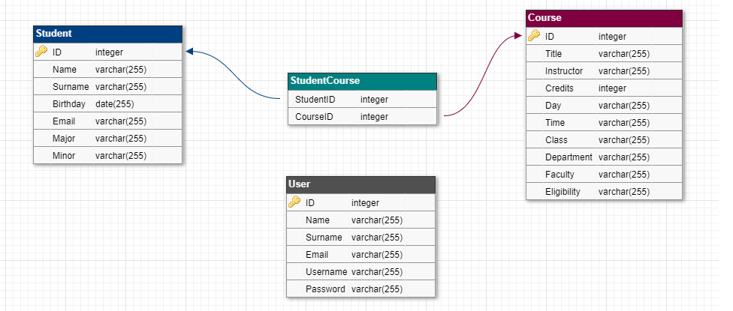

The database is made out of four tables: Student, Course, StudentCourse and User.

The user contains all the users of the system. It contains six fields as it is seen in the diagram. For security purposes, the passwords are not saved as plain text but as hashes. They are hashed using md5 algorithm.

The student table contains all the student of the university that are registered on the database.

The course table contains all the courses offered in a single semester.

The studentCourse table is used to resolve the many to many relationship between the student ad course tables to two one-to-many relationships between student and studentCourse and course and studentCourse respectively.

# **Website Usage**

Register a new user

1. Log In Window

Go to UNYT page



Trying to login with wrong credentials will display an error message



Pressing Log In without entering anything:



2. Register a new User:

After the user is registered by pressing Login the system will return to the log in page.

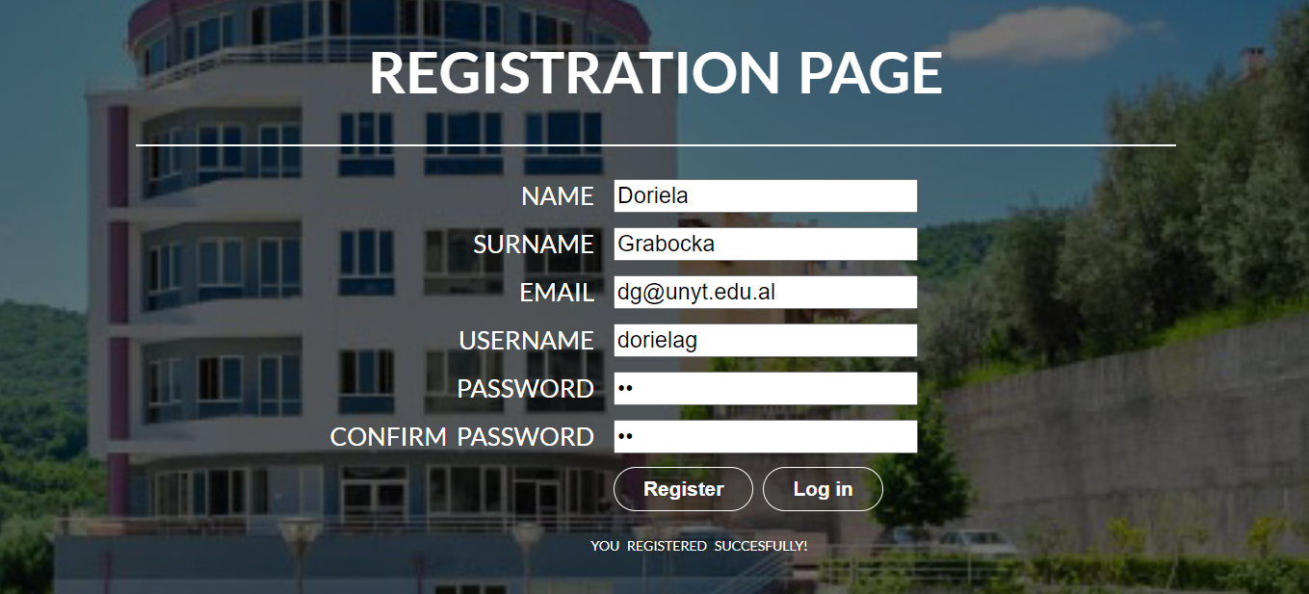

Go to the Login page

When trying to register a user that has already registered the system will display an error message indicating the situation.

Registering a user that exits

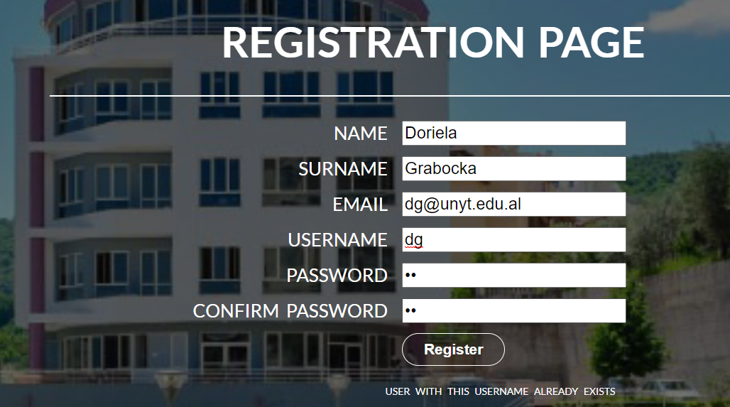

Log out

Help window

3. Main window:



Go to UNYT Social networks

When the user logs out the session variables are destroyed and user is redirected to the log in page.

By clicking in one of the icons in the footer, the user can go to the social networks of UNYT.

4. Help Window



5. Add a student

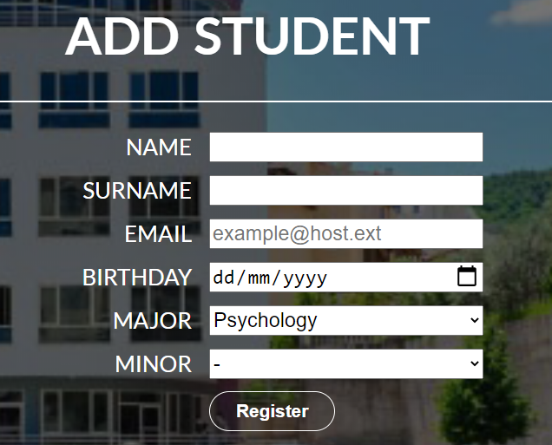

After successfully adding a student, a button to return to the main page will appear. By clicking it, the user will return to the main page. In order for the registration to be successful all, the fields must be set and the student must be more than 17 years old. Otherwise, the registration will fail displaying proper messages on how to handle the situation.

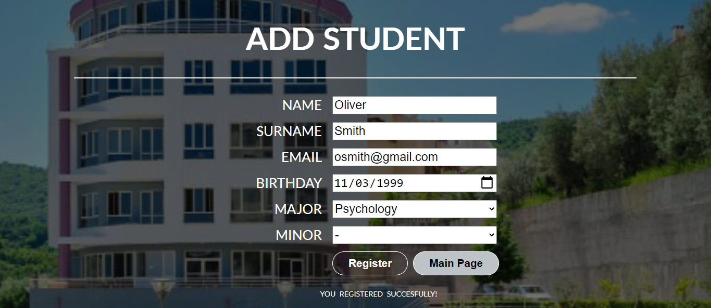

Go to the main page

Trying to add a student that is already registered will fail. The system will display an error message indicating the situation. The database check the email of the supposed new user if it exists or not. The age of the student should be over 17 years old too.

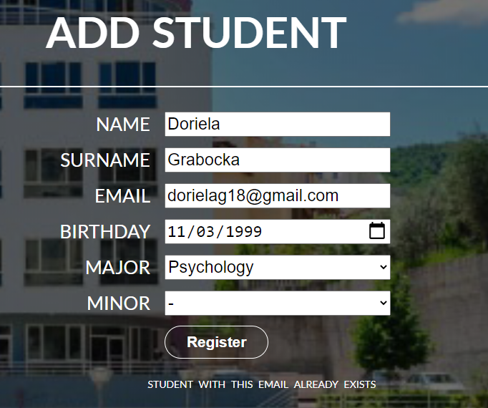 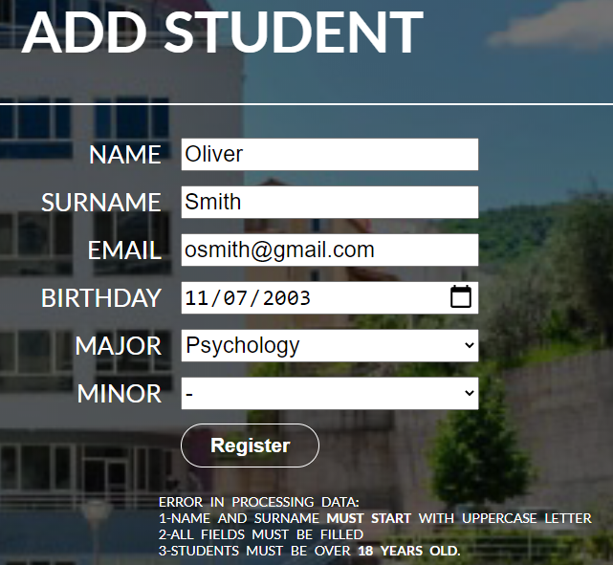

Figure 1: Adding a student that is registered already Figure 2: Adding a student that is less than 18 years

6. Add Course



Like in the case of adding a student, even here after the course has passed all the validation a button to go to the main page will be displayed.



Go to the main page

Trying to add a course that is already registered will fail. Moreover, there are restriction on the way data is entered. In case they are violated the system will not accept the data and it will show the appropriate messages in order to help the user solve the situation.



Figure : Incorrect data



Figure : Existing Course

7. Search Student

Go to main page

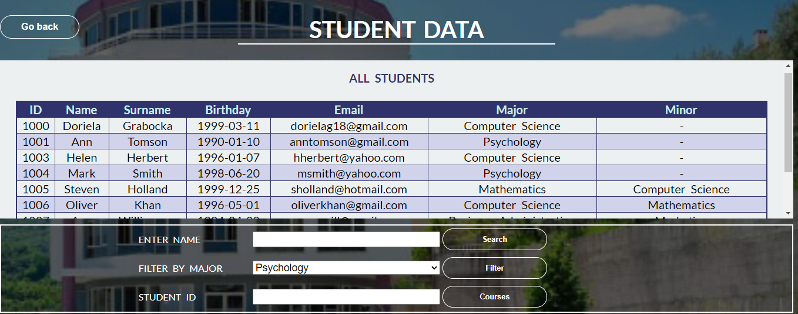

Search a student by name: entering the name or part of it in the text box and then pressing search will display all matches.





Filter students by major:

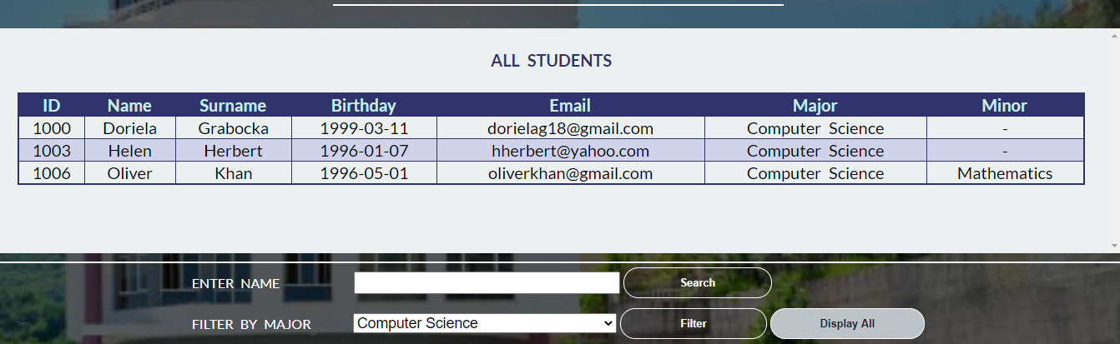

Display the whole list

Checking the courses of a student: by clicking on the corresponding row on the table the and then clicking the Courses button the courses where the student is enrolled will appear.

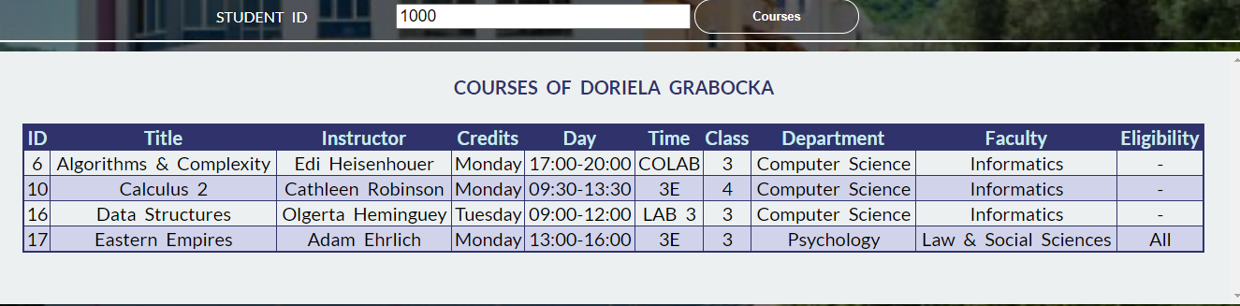

8. Search Course

Go to main page

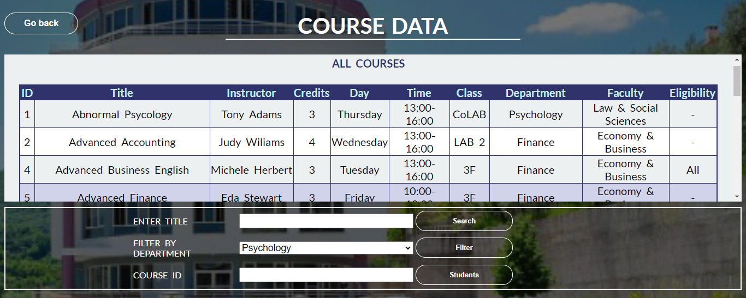

Searching a course by title: by entering the full or partial title of a course and pressing the Search button the user will be able to see it.

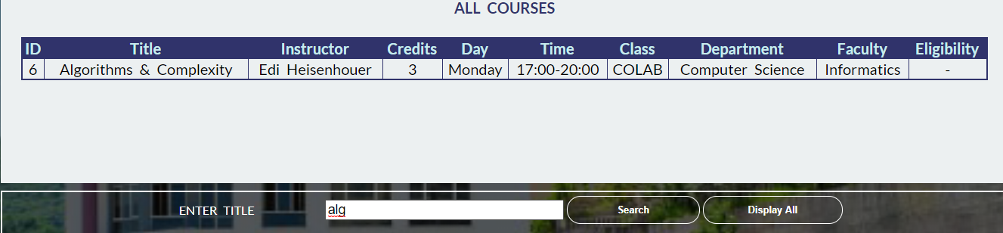

Filtering the courses by degree:

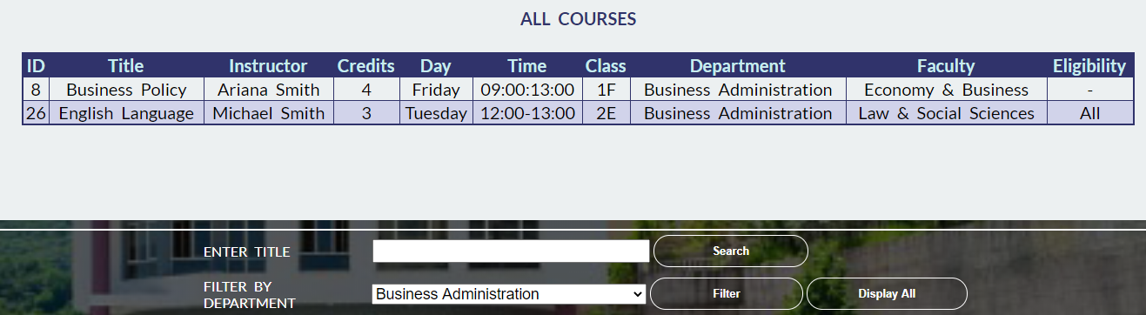

Checking the student enrolled in a course

By clicking on the row, corresponding to the course on the table and hen clicking the Students button the participants will be displayed.

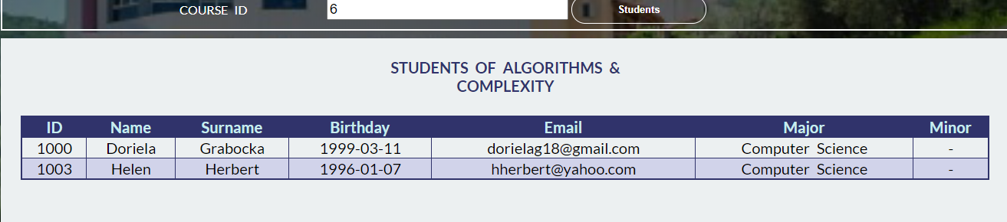

9. Assign Course to Student

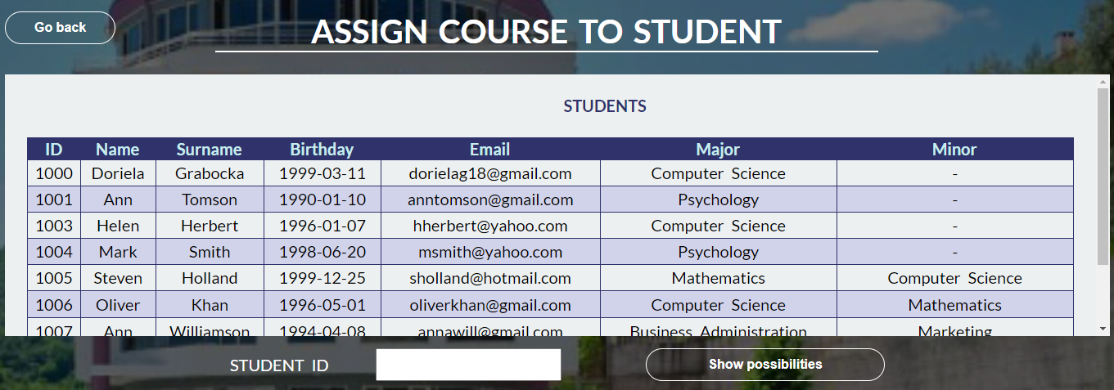

By clicking on one of the rows of the table, the textbox will automatically be filled with the ID of the corresponding student. By pressing the Show possibilities button the table of possibilities will appear.

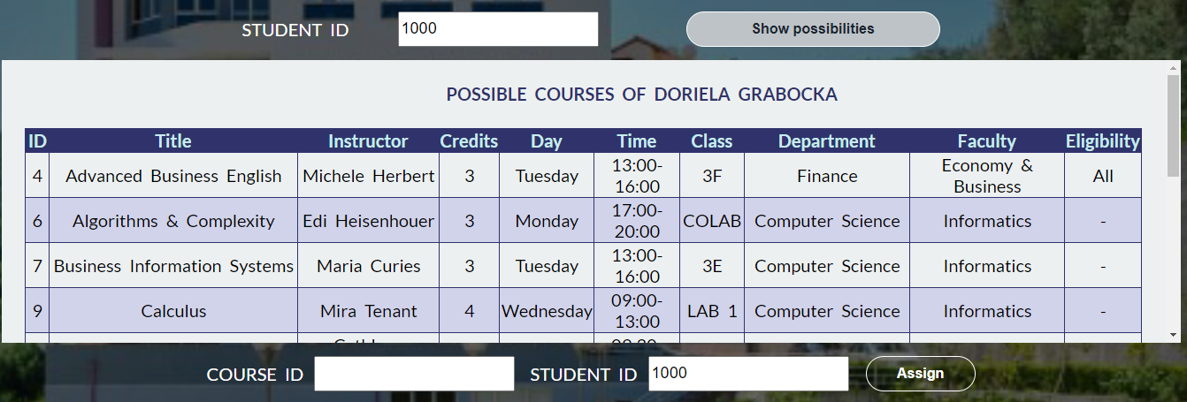

By clicking in a row in the Possible Courses table, the Course ID textbox will be filled. It is a read-only textbox meaning that the user cannot entering anything there. All textboxes in this page are read-only so that the validation process can be easier and faster.

If the student already has a certain course than it will not be added and a message will indicate this situation.



Otherwise, the course will be added.



**How to use the application**:

In order to enter in the application, the data in the User table in the database should be used.

The user can enter by using one of the following credentials:

|  |  |
| --- | --- |
| **Username** | **Password** |
| annsmith | admin |
| robertgutenberg | admin |
| johndoe | admin |
| dg | dg |

Moreover, due to the session variables if the user tries to enter in a protected page (pages accessed after login), without logging in, the Log In window will appear.